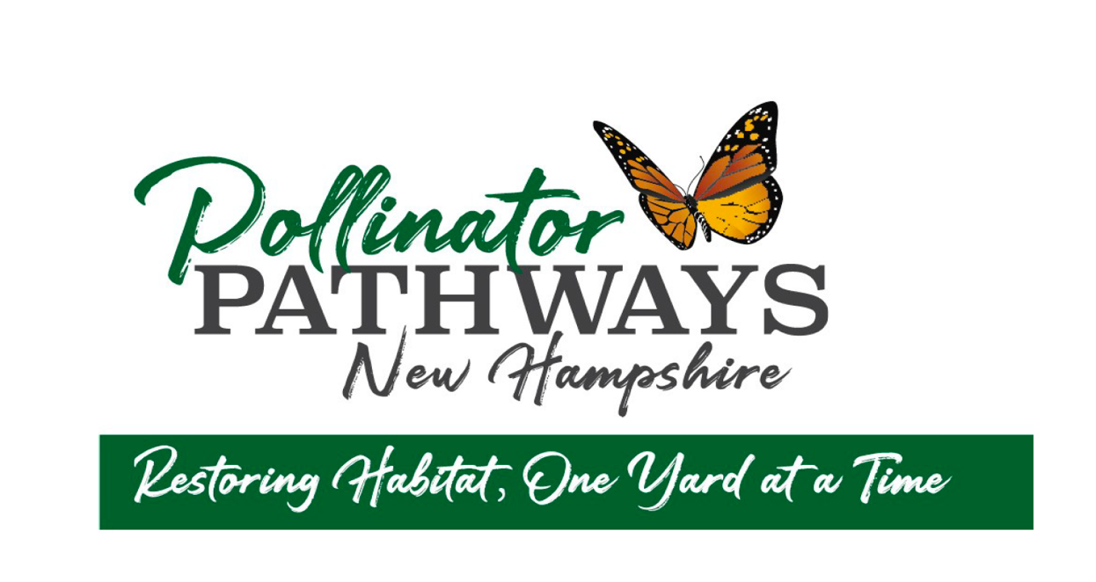
August, 2022

Dog days of summer!
I confess to being stuck in air-conditioned doldrums when it’s 97º out. I have heard that August is the time to sit back and enjoy what one has planted, and that sounds like a really good idea right now. Leave the flowers to the bumbles and butterflies and critters….

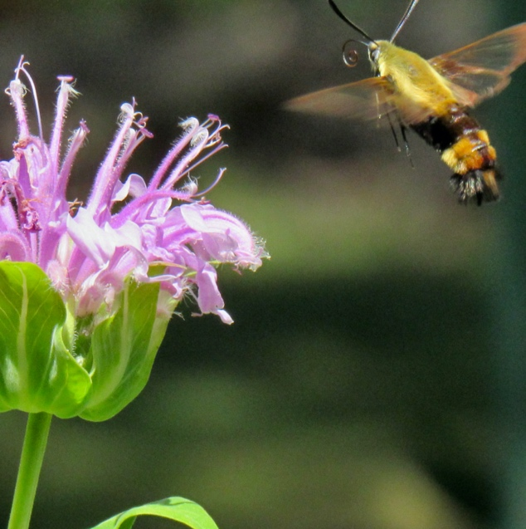
….including Hemaris diffinis!

This summer we’re experiencing what birders would call an “irruption” of snowberry clearwing moths! (AKA hummingbird or hawk moths) They seem to be in every garden. My patch of Monarda fistulosa hosts three or more each time I go out to observe.
They’re challenging to photograph. My non-SLR, non-manual focus camera goes OOF (out of focus) whenever the wee moth flits off to the next flower. I’ve made some determined attempts, one of which I include because you can see its furled tongue, or proboscis. It sips nectar from flowers with that squiggly tongue, picking up pollen on that fuzzy abdomen as it feasts. Clearwing moths are members of the sphinx moth family and are day-flyers, rather unusual in the moth clan. Did you know that all butterflies and moths have scales on their wings? The clearwing loses most of its scales on its first flight making the wings almost transparent!
Larval hosts for the snowberry clearwing moth are viburnums, dogbane, and some of our honeysuckles.

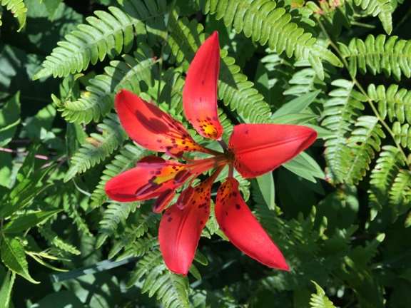
Before this stretch of dog days hit I happened upon a fabulous native flower while hiking a power easement. I had never seen it before. iNaturalist id’ed it as a wood lily, Lillium philadelphicum. Turns out this flower likes power easements. “Since powerlines somewhat reproduce their original habitat (fire-cleared forest clearings) replied one expert on the Native Plants of New England Facebook page, “those sites tend to be the habitat wood lilies prefer, especially the sandy-soiled, low-nutrient sites they share with sweet fern, pilewort, etc.”

Have you seen any wonderful new native wildflowers this summer? Send us photos!

What’s Up with our Partners?

From Facebook’s pages:
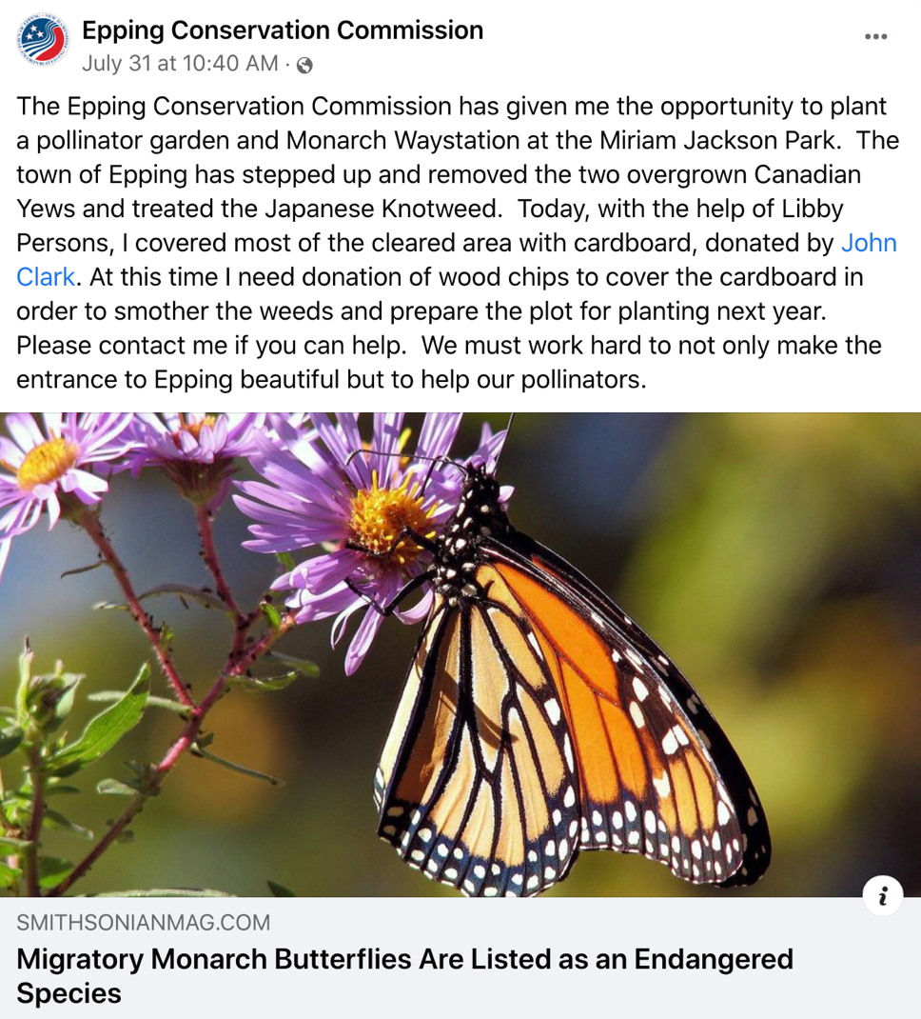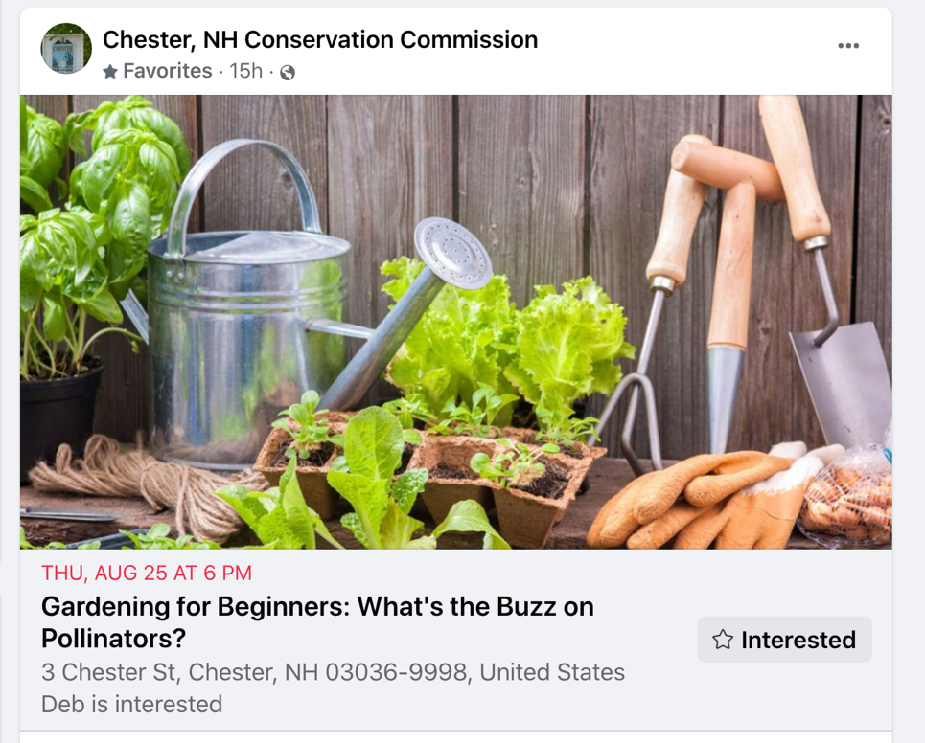

- Thank you to Cris Blackstone and the Newmarket Conservation and Recreation for asking us to set up for their first annual garden tour.

- Artists Liz Hughes and Asia Scudder are establishing a studio behind the general store in East Kingston and are already at work on a pollinator garden there.

- Thank you to Hampstead’s Cheryl Keim who took a terrific group of pollinator-smart gardeners on a tour of her rewilded yard (as we attempted not to step on her many pet chipmunks)! We were inspired by all Cheryl has accomplished on her property.

- In Kingston, a monarch waystation at the recreation center is undergoing a much needed facelift. Thank you to the five intrepid volunteers who weeded there on a hot night. We need ongoing help if you live close enough to lend a hand. Please email me at evynathan@comcast.net

- The garden at the Kingston Community Library is attracting throngs of pollinators. Bluebirds have been nesting in butterfly boxes opened up for them by squirrels. We hope to hold another library garden walk when the temps cool off a bit.

- The Library and PPNH offered a raffle for a full pollinator garden kit (28 plants!) complete with designs and instructions, compliments of Bagley Pond Perennials. Congrats to the happy winner. Hope the plants are taking off.
https://bagleypondperennials.com

- The seed library in at the Kingston Library, open to all, has been popular. We’ve had to refill seed packets more than once. Many thanks go out to Melissa Mannon, our new library director, for her cooperation with this project, her enthusiasm and her gardening know-how.

- The monarch waystation behind the Fremont Library is going strong. On a recent walk there I counted ten monarchs gliding around among the field of milkweed plants!

Send us your pollinator news! We’d love to include it in our next newsletter!

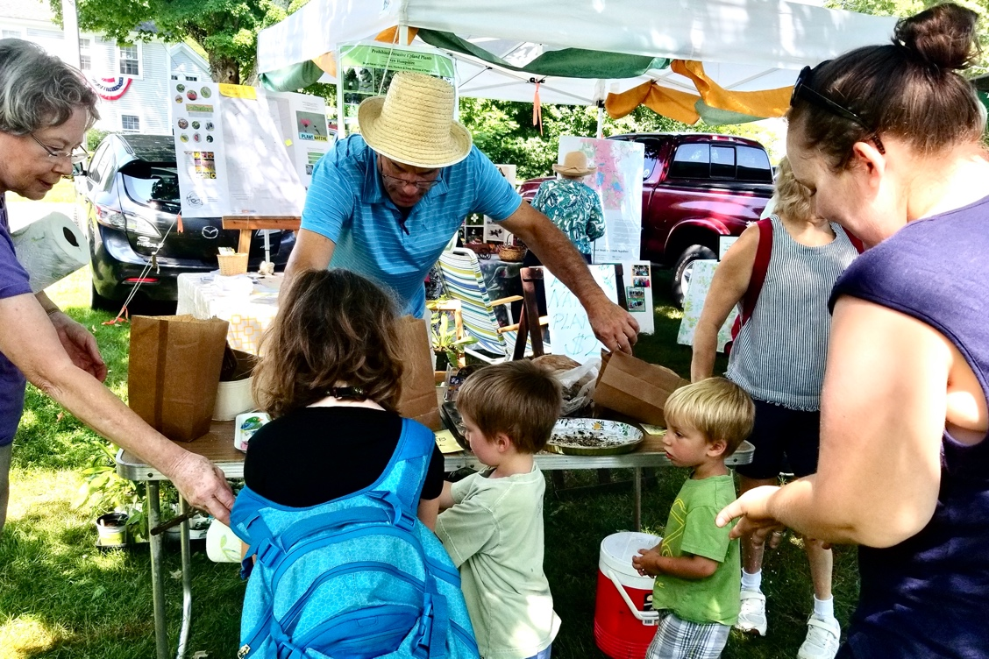

- Finally, our annual Kingston Days Festival on the Plains will happen tomorrow, August 6^{th,} and 7th. Pollinator Pathways will be there with all of our brochures and milkweed seed. Come and visit us, we’ll be set up near Rick’s Restaurant. Hope to see you there!

Evy, Marghi, Elizabeth and Melanie

