Agenda – March 8, 2023
- Mission statement – next page
- Summer camp –
  - We need counselors!!
- Senior activities – cards coffee and conversation Friday March 10 with Humana rep
- History of Kingston DVD from Scott – thanks! –May 13 and May 20 at the library
- Playground update
- Movie nights –Sat 2/11/23-
- state parks talks on moose March 25th – thanks Scott!!
- Easter do we have enough stuff – we need large prizes – April 8 plan!!!!
- 2 June activities with Hampton Rec – botanical gardens and Joseph and the amazing technicolor dreamcoat
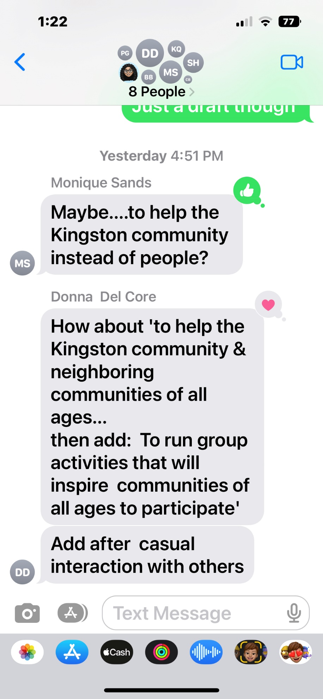
Decisions based on money were made…
NEXT MEETING – February 8, 2022

